Committee Training Handbook 2024-25

Congratulations on being elected onto your sports club or society committee! Please use this training handbook, throughout the committee training day and as a resource you can use over the academic year.

NAME:
CLUB/SOCIETY:
COMMITTEE POSITION:

Introduction to the Students’ Union

Join In. Speak Up. Be More.

The Students’ Union is here to give you opportunities, build your community and represent your voice during your time at University. You are a member of a 30,000 strong organisation and we support and engage with all of you across all campuses, courses and backgrounds.
Elected by students, the presidents and officers represent you in shaping The Students’ Union policy. They run campaigns and attend meetings in various levels of the university to make sure your views are heard. At any point in the year you can submit an idea online; if enough students agree with it The Students' Union will work to try to make it a reality.
You will be predominately working with the Opportunities team within the Students’ Union. You may also meet and work with other teams, such as the Presidents team, Community team, the Commercial team and the Representative team.

The Opportunities team:

- Kelly Howard – Opportunities Manager
- Alice Willumsen – Club Development Manager
- Ryan Sampson – Club Coordinator
- Magdalena Mohorkova – Societies Development Coordinator
- Opportunities Assistant
- Trips & Transport Assistant
The Presidents team 2024/25:
- President – Kolawole Samuel Olure
- VP Sports & Health – Muhammad Habib
- VP Societies & Communication – Umar Abbasi
- VP Community & Welfare – Lubyna Gardenezi
- VP Education – Sabiha Khan

If you are a member of a sports club you will also work and meet with different members of the Centre for Sport team:

- Alex Isaac – Head of Sport
- Guy Coles – Performance Sport Manager
- Tamara Getter – Sport Experience Manager
- Vicki Moulder – Sport Development Coordinator
- Adam Lancaster – Lead Strength & Conditioning Coach

Q) What is the purpose and role of a Students’ Union?

Q) What are the 5 Students’ Union Presidential roles?

1)
2)
3)
4)
5)

Q) What are your main roles as a committee member?

Q) What 4 things do committee members need to do/complete over the academic year to have their committee role appear on their Higher Education Achievement Report (HEAR)?

1)
2)
3)
4)

In between now and September, your club/society committee will need to complete a variety of admin, ready for the academic year.

Committee Checklist:

- Handover document
- Kit & equipment inventory form
- Budget form
- Club/Society risk assessment
- Club/Society constitution
- Development form
- Freshers fair application

Finance

Your club/society account is held within the Students’ Union bank account. There are NO external bank accounts for sports club or societies. DO NOT open a bank account for your club (including paypal), this is fraud.

All clubs/societies should be self-sufficient. The club/society income should be equal to its expenditure.

Q) What are 3 different types of income for a sports club or society?

1)
2)
3)

Q) What are the 3 main methods a sports club or society can use to spend their funds?

1)
2)
3)

With authorization from the Student’s Union, committee members can purchase items on behalf of the club/society and get the money reimbursed using a payment voucher form. Payment vouchers can be found on the Students’ Union website and must be emailed to suopportunties@uwe.ac.uk to be processed. For a payment voucher to be accepted you must include the following;

- VAT receipt for all purchases
- Your details, including your bank account number & sort code
- Detailed breakdown of the purchase(s), including descriptions of the items and price
- Two other committee members CC’d into the email to suopportunities@uwe.ac.uk
- For any fuel claims, the milage of the journey is needed to work out the value of the claim

*PLEASE NOTE: Sports clubs and societies cannot claim for or purchase alcohol using account funds.

Using one or more of the receipts below, fill in the payment voucher below. Either print out the image of the payment voucher below or you can find an electronic copy of the payment voucher form by clicking here!

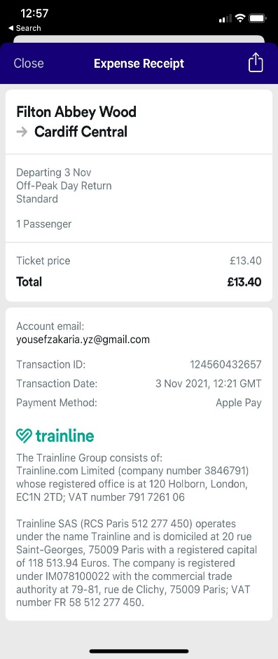
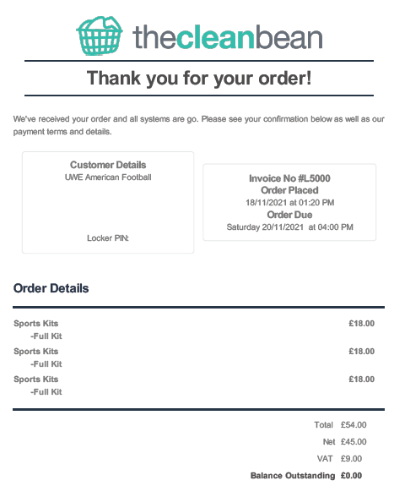

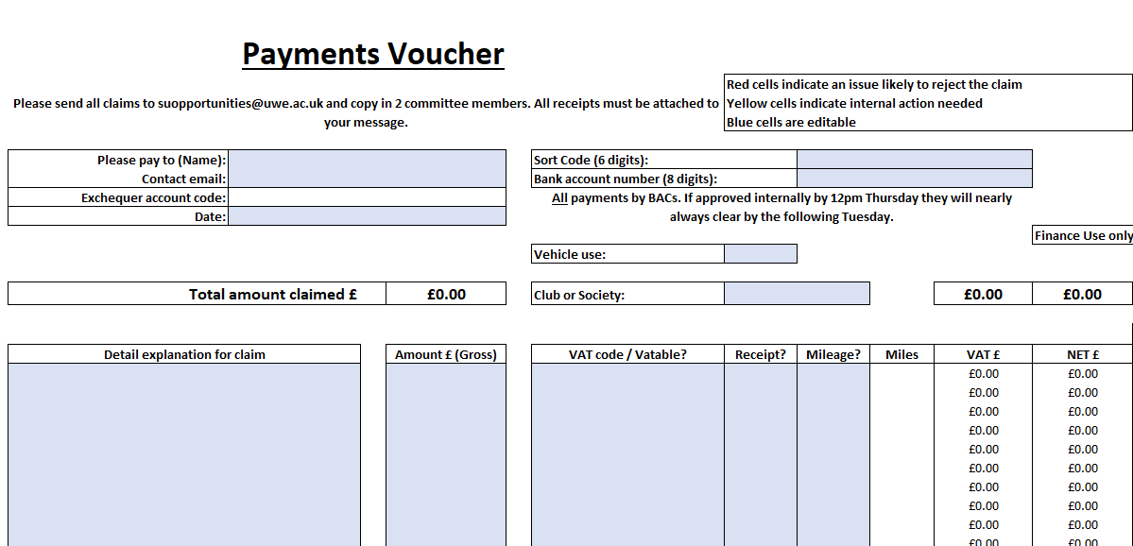

Before the start of the academic year, your club/society will need to submit a budget form for the year. Filling in your budget submission is one of the most important things that you will do in preparation for your year of running your club/society. The budget form helps you as a committee, plan and predict your income and your expenditure, to ensure your club/society does not end up in the negative! The budget forms can be found by clicking here! If you would like to see your previous years budget form to use as a guide, please ask your outgoing committee or email suopportunities@uwe.ac.uk

Q) What are 3 different costs that your club/society will need to pay for this academic year?

1)
2)
3)

Q) How much income do you predict the club/society will bring in from membership fees? This can be calculated from the predicted number of members x cost of membership. Or for NFI societies the number of members x £2 (capped at 100 members).

Predicted number of members:
Cost of membership:
Predicted membership income:

Before any self-employed services (such as photographers, DJs etc.) and sporting official can be paid by the Students’ Union they must complete a determination form and send over an invoice for their services.

Once they have filled in this form and it has been approved by our finance team, we can pay them by BACS/invoice. Do not give out any cash for any officials/services. We will not reimburse you if they haven’t been through this process!

Q) Before any official can be paid for their services, they must fill in a _________________________ and send over an __________________ before they can be paid.

Any invoices we receive must have the following:
- Be addressed to ‘The Students’ Union at UWE’
- Date of services/date of invoice
- Details of services/charges
- Unique invoice number
- Price breakdown including VAT (if applicable)
- Their company name/name, address and bank details of where to make the payment

Events, Trips & Transport

Below is the process for booking events through the Students’ Union:

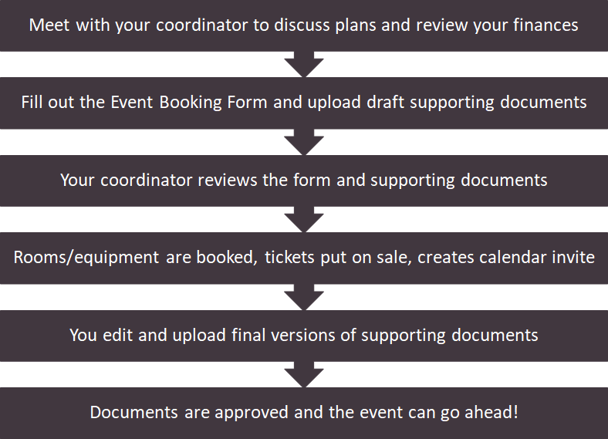

All forms for event booking can be found on the following weblink: https://www.thestudentsunion.co.uk/events/bookyourevent/

Q) How many weeks notice will we need for your events?

If you wish to have an external speaker at any event including online, you will need to submit an external speakers form. Anyone who is not a student or member of staff here at UWE is considered an external speaker. This form must be submitted a minimum of 14 days in advance of the date of the event. For any religious or political speakers, we will require 21 days notice to allow the University to adequately plan for the event. Forms arriving after this time will not be approved. Further information regarding external speakers including the external speaker form, can be found on the following weblinks:
https://www.thestudentsunion.co.uk/dosomething/externalspeakerform/
https://www.thestudentsunion.co.uk/dosomething/howtoformsanddownloads/formsanddownloads/

Before any society or sports club trip can take place, we must receive a trip form. Trip forms can be found on this weblink https://www.thestudentsunion.co.uk/dosomething/howtoformsanddownloads/tripsandtransportbookingform/

Q) How much notice do we need before any UK Trip?

Q) How much notice do we need before any international trip?

Give the Students’ Union as much notice as possible, especially if you need transport or accommodation booked, or if there is a competition deadline.
Provide us with as much detail as possible; links to accommodation, tickets, estimated cost per person etc.

Q) Can you use your own transport?

Forms of transport we can book for you:

- MPVs, Vans
- Minibuses (16-33 seats)
- Coaches (49-70 seats)

Q) What 2 things must your committee complete before going on a trip?

1)
2)

TASK) Plan your own trip – create your own trip and answer the series of questions below, which are taken from the trip form.

COMMITTEE TRAINING - TRIP FORM
Please choose the phrase that best describes the trip you are organizing:
- Ticket sales will cover the total cost of the trip including all activities, travel costs and accommodation (where applicable).
- We will need to use funds from our account to pay for some or all of the costs of the trip.
- This trip is free, there are no associated costs or it is a Students’ Union Staff booking.
Specify the type of trip you are organizing:

- One-day trip will start and finish on the same day requiring NO international travel
- Trip will last more than one day and/or requires international travel
Name of trip organizer:

Organizer’s Telephone number:

Organizer’s email address:

Date of trip (enter the date in the format DD/MM/YYYY):

Time of departure (enter time in 24hr format HH:MM):

Time returning to campus (enter time in 24hr format HH:MM):

Name of destination/venue:

Address of destination/venue:

Name of sports club / society / staff:

Please give a brief description of the nature of the activity that will take place on this trip (e.g. Hiking - Travelling to Snowdonia, camping overnight, hiking up Snowdonia following The Llanberis Path. E.G. Dance - Travelling to Nottingham, competing in National Dance Competition)

Trip Title (This will help us identify the trip amongst other bookings and will also help with communications):

Name of first aider #1: | Name of first aider #2:
If you require any equipment owned by the Students’ Union, specify in the space below: If you require equipment this must be collected by 12pm on the day of your trip. If your trip is on a weekend this must be by 12pm on the Friday before unless otherwise agreed with a member of the Opportunities Team.

You must provide a detailed list of what you want to use on the trip. An example of what we are looking for is as follows:
Number x Brand Item Name
For example:
4 x Naish Kailua Beginner Boards
If you want to take equipment abroard, please include the replacement value of each item at the end:
4 x Naish Kailua Beginner Boards (£1600ea.)
NOTE: If you don't want to use any equipment, simply state 'none'
Will you need weekend or night-time access to the opportunities store room?

Is this trip covered by your club or society’s general risk assessment?
If your Club, Society or Network have not produced a general risk assessment (or you are not sure whether this trip is covered by such a risk assessment) it is important that you provide one for the trip to be authorized.
- Yes
- No
The Students' Union has a number of transport options it can offer you to help make your trip happen.
We currently lease one vehicle on an ongoing basis. This is a 9 Seat VW T5 Shuttle (which we refer to as the People Carrier). Any other vehicles are rented from one of our preferred suppliers. All hire vehicles (whether SU or External) are rented on a 24 Hour hire period. This means that if you need a vehicle from 4pm on Friday until 4pm on Saturday, you will only be charged for 1 day's rental. Please consider this when you book.
Will you be travelling by own transport?
- No
- Yes – fuel will be claimed back via our account
- Yes – We will not be claiming fuel through out account
Rented hire car:  - None  - 1  - 2  - 3  - 4  - More? (SU will contact you | Rented 7 seat people carrier:  - None  - 1  - 2  More? (SU will contact you)
9 seat MPV (SU if available, rental if not):  - None  - 1  - 2  - More? (SU will contact you) | Mini bus (Rental 12 seat max.):  - None  - 1  - 2  - More? (SU will contact you)
Rental Van:  - None  - Small Van (transit connect / VW Caddy)  - Short wheelbase van (transit/vivaro)  - Long wheelbase (transit LWB / Iveco daily / sprinter)  - Jumbo van (Jumbo LWB sprinter) | Towing Vehicle:  - None  - SU 9 Seat MPV (2200kg kerb weight)  Rental 4x4 (1900kg kerb weight)
Do you require a driven vehicle (i.e. you do not need to provide a driver)  - No  - Yes – Driven mini bus  - Yes – Driven coach | Flights:  - No  - Yes
List the names of any registered and/or MiDAS assessed drivers for this trip? This should include the name of anyone who is driving their own vehicle and wishes to claim fuel back after the trip from you activity's account; as well as any MiDAS drivers required for larger vehicles.

Online payments - If you choose to have online payments, this will remove the need for you to populate the Participant's List manually. However, you will still need to create a Participant's List so that the names of those who buy tickets can be added to it. This must be done before tickets will be put on sale. It is also imperative that an event be created on the The Students Union at UWE Page for your Club or Society so that tickets can be attached to that event. You do not need to inform the SU of the names of these lists or events, we can see them...but you MUST create them. If you don't use online payments, then these points do not apply.
Do you require any online payments to be set up so members can purchase them to go on your trip?
- No, we will submit a participant list manually
- Yes
Additional Information – please supply any other information you feel we should know to assist with booking your trip.
Once you have submitted your booking below we will process your trip form. The Students' Union will e-mail you when we are processing your trip and you will be notified when your trip has been authorized.

Marketing, Social Media & Website

It is important as a sports club/society that you ensure members join and take part in activities, collaborate and reach out to other clubs/societies to continually get more students to join in. This will require efficient marketing and communication to ensure student engagement.

We have some tips for you to communicate effectively with your members:

- Don’t rely on one method of communication. Not all students have Facebook so explore all avenues.
- Give members notice. If you are planning something let them know so they can note it down in their calendars.
- Be responsive back. If a member or student messages, get back in touch with them as soon as possible so they know you are listening to them.
- Be detailed and concise. People like to be informed, but not spammed.

Q) What are 3 ways you can be engaging on social media?

1)
2)
3)

SU top 10 tips for Social Media:

- Celebrate your achievements
- Be more certain, “we will do…” , “we are…”
- Include a call to an action, invite a response from your audience
- Try to not overload with information
- Always tag @TeamUWEbristol / @thesuatuwe_societies in every post so we can see it! Or tag @thesuatuwe/ @thesuatuwe_glenside / @citycampusuwe
- Keep it simple and to the point
- Use positive vocabulary
- Talk to people directly, use words like “you”
- Help each other out - follow, like, share each others posts!
- Try to use the resources available to you - we can provide you with the UWE colour/branding guidelines as a starting point!

There are a lot of resources available for you to use on the Students’ Union website. These can be accessed using the Admin Tools.

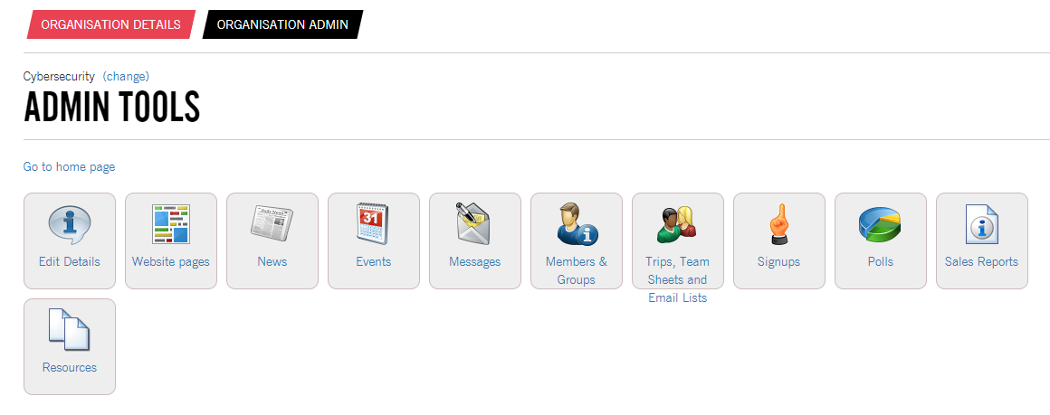
The admin tools have the following functions that you can use:

- News - Create News articles that will appear on your webpage.
- Events - Set up and create events, which your coordinator can add tickets too.
- Messages - Send email messages to your members.
- Members & Groups - View who has purchased different memberships/products.
- Signups - Create signups for your activities/sessions.

Q) Have a look at your Student’s Union club webpage, what are 3 things you could add / change to the webpage, to make it more engaging for new students?

1)
2)
3)

All social media and webpages needed to be inclusive and accessible to all! Here are some things to think about to ensure your club/society social media channels and webpages are as inclusive and accessible as possible!

- Always add descriptive captions/alternative text - this will allow people to visualize images when they can’t see them.
- Always add video captions/subtitles/closed captions to your videos/live streams - this is crucial for those with hearing impairments.
- Write accessible text - ensure that your text and writing is clear and could be read by a screen reader. Avoid fancy fonts, abbreviations and aLtErNatInG cApS.
- Provide as much information as possible - such as images of your committee, locations/maps, images of the locations of your activities - this can help put students at ease when joining your club or society!

TASK) In groups of 4 or 5 (those sitting around you), create a social media post for a cause of your choice (e.g. a campaign, charity event, fixture or competition).

COMMITTEE TRAINING – SOCIAL MEDIA POST
What is the purpose of your social media post?

What would you like the outcomes/impact of your post to be?

What resources will you need to make your post?

Any other information / design ideas?

Health & Safety

Risk Assessments

Each sports club and society will need to have an up to date risk assessment which encompasses all of the risks from your usual activities, such as your activities, training, competitions and fixtures. A risk assessment will also need to be completed for any activity, event or trip that is outside of your usual activity.

The risk assessment should list all of the potential risks (anything that could go wrong), and how you’re going to prevent that risk from happening. Each risk, will be need to be scored on its ‘severity’ and it’s ‘likelihood’ of happening. The likelihood score and the severity score are then multiplied together to give a risk level. For example, if a risk is assessed as having a likelihood of 2 (unlikely to happen), but has a severity score of 4 (would cause major injury), this would give a risk level score of 8.

Very likely  5 | 5 | 10 | 15 | 20 | 25
Likely  4 | 4 | 8 | 12 | 16 | 20
Possible  3 | 3 | 6 | 9 | 12 | 15
Unlikely  2 | 2 | 4 | 6 | 8 | 10
Extremely unlikely  1 | 1 | 2 | 3 | 4 | 5
Likelihood (L)  Severity (S) | Minor injury – No first aid treatment required  1 | Minor injury – Requires First Aid Treatment  2 | Injury - requires GP treatment or Hospital attendance  3 | Major Injury  4 | Fatality  5

The risk assessment score is then compared to the risk level table below, which indicates whether or not the risk can go ahead, if further action is needed to prevent the risk or if the activity/risk needs to be stopped.

POINTS: | RISK LEVEL: | ACTION:
1 – 2 | NEGLIGIBLE | No further action is necessary.
3 – 5 | TOLERABLE | Where possible, reduce the risk further
6 - 12 | MODERATE | Additional control measures are required
15 – 16 | HIGH | Immediate action is necessary
20 - 25 | INTOLERABLE | Stop the activity/ do not start the activity

Q) Using the tables above, calculate the risk assessment score, and the action level for the following risks (these are all examples from previous risk assessments!).

Sport | Potential Hazard/Risk | Severity | Likelihood | Risk level score | Risk level
Boat (example) | Rowing Erg: potential trip hazard | 1 | 2 | 2 | Negligible
Archery | Bow sting- when releasing the arrow, the bowstring can graze/strike the archer in the inside of the elbow/forearm and cause minor injury such as bruising. | 1 | 5 | ? | ?
Cheerleading | Falling from height during stunts | 3 | 2 | ? | ?
Football | Astro burns | 1 | 3 | ? | ?
Netball | Injury from post falling / colliding with posts | 3 | 3 | ? | ?

Q) Give the scenarios below, a severity and a likelihood score, and calculate the risk level score and risk level.

Sport | Potential Hazard/Risk | Severity | Likelihood | Risk level score | Risk level
Cycling | Traffic when cycling on the road
Trampoline | Broken / faulty springs
Volleyball | Collision with volleyball net
Windsurf | Cold water / hypothermia
Lacrosse | Head injury from stick check/contact

Q) What 3 criteria do you need to be able to complete the MiDAS course?

1)
2)
3)

Any society or club that wants to cook or bake food for an event/activity, the individual(s) preparing the food must have a food hygiene certificate. These courses can be found online, and usually cost around £10-£15 to complete. You must send evidence of the food hygiene certificate to suopportunties@uwe.ac.uk .

Incident Forms

The Students’ Union have 3 types of incident forms you will need to be aware of:
- Accident form
- Equipment incident form
- Vehicle accident form
These forms can all be found on the following weblink: https://www.thestudentsunion.co.uk/dosomething/howtoformsanddownloads/formsanddownloads/

There is also a head injury protocol you and your club/society will need to be aware of. The Head Injury protocol must be followed for any suspected, or actual Head Injuries that have occurred during any training, matches or activities. The Opportunities Manager must be informed whenever a Head Injury has occurred, and the relevant documents completed and returned. All documents are resources can be found under ‘Head injury reporting’ on the following weblink; https://www.thestudentsunion.co.uk/dosomething/howtoformsanddownloads/formsanddownloads/

All sports clubs will be assigned a first aid bag for the academic year, which can be used at fixtures/competitions. All of these first aid bags should have a ‘Concussion recognition tool’ inside, imaged below.

Q) What are the 3 head injury documents available on the Students’ Union website?

1)
2)
3)

Q) What are 5 signs or symptoms of concussion?

1)
2)
3)
4)
5)

IN THE EVENT OF A SERIOUS INCIDENT THAT MAY WARRANT THE USE OF ANY OF THE EMERGENCY SERVICES THE FOLLOWING PROCEDURE MUST BE ADHERED TO:

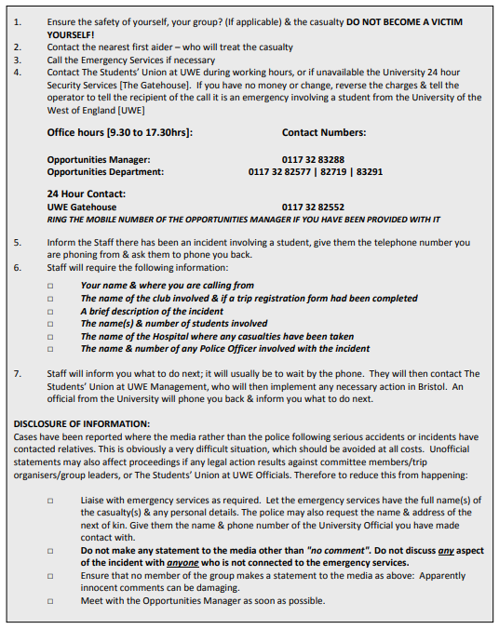

Sustainability, Greener Futures & Fundraising

Q) What is the Greener Futures project?

Q) How much money could your club/society win for taking part in the Greener Futures project?

Q) What are the 5 different sections the Greener Futures challenges are split into?

1)
2)
3)
4)
5)

Q) Sustainability pledge - What are 3 things your club/society could do this academic year to be more sustainable?

1)
2)
3)

TASK) In groups of 4 or 5 (those sitting around you), plan a fundraising event to raise money for a charitable cause.

COMMITTEE TRAINING – FUNDRAISING EVENT
Event name: | Charity:
Event Description:

What resources will you need for your event?

How much money would you like to raise?

Do you need any venues/facilities hiring for your event?

Do you need any equipment booking for your event?

Any other information?

Conduct & Speak Up

Conduct & Codes of Practice

All Sports & Societies members must read and abide by the Code of Practice, and all committee members must sign their Club/Society Constitution.

The Students’ Union Activities Code of Practice can be found on the following web link;
https://www.thestudentsunion.co.uk/dosomething/sports/codesofpractise/

Q) What could be a potential consequence if the codes of practice are not followed / adhered to?

Speak Up

Q) What are 4 methods that could be used to intervene during a difficult situation (the 4Ds)?

1)
2)
3)
4)

Q) Fill in the gaps on where you can report inappropriate, abusive or antisocial behavior

- If it is an emergency call _______
- On campus, if it is not an emergency you can call the _____________________ on 0117 3286404
- UWE ______________ and _____________ tool can be found on the following web link; https://www.uwe.ac.uk/life/health-and-wellbeing/staying-safe-on-and-off-campus/report-and-support
- The Students’ Union at UWE Staff
- The Centre for Sport Staff Team / University Staff
*PLEASE NOTE: You should always try to report an incident ASAP through the appropriate communication channels.

BUCS & BUCS Play (TO BE COMPLETED BY SPORTS CLUBS ONLY)

Q) What does BUCS stand for?

Q) Every athlete who wishes to compete in a BUCS event or for a BUCS team must download and create an account in which app to be eligible to participate?

Q) On BUCS play, what are the 4 jobs a captain must do?

1)
2)
3)
4)

Q) How many credits does a student need to be studying to be able to participate in any BUCS fixture or competition?

Q) For Wednesday fixtures, when do you team sheets need to be submitted by on BUCS play?

Q) For all individual events, athletes will need to enter themselves into the event on BUCS play. What day and time is this deadline normally on BUCS play?

BUCS provide a number of resources which can be used to help with the use of BUCS play, one of which is the BUCS Captains Pack. These can be downloaded form this webpage; https://www.thestudentsunion.co.uk/dosomething/howtoformsanddownloads/formsanddownloads/

BUCS have general regulations and sport specific regulations that must be followed. Make sure you are familiar with these. All rules and regulations can be found on the following web link; https://www.bucs.org.uk/rules-and-regulations.html

If a team feels, upon arrival or during a fixture, that the conditions do not adhere to those outlined in the BUCS rules and regulations, they should complete a ‘BUCS Playing Under Protest Form’ as soon as the grievance is noted.

The regulations for playing under protest can be found on the following web link; https://www.bucs.org.uk/rules-and-regulations/general-regulations/reg-12-playing-under-protest.html

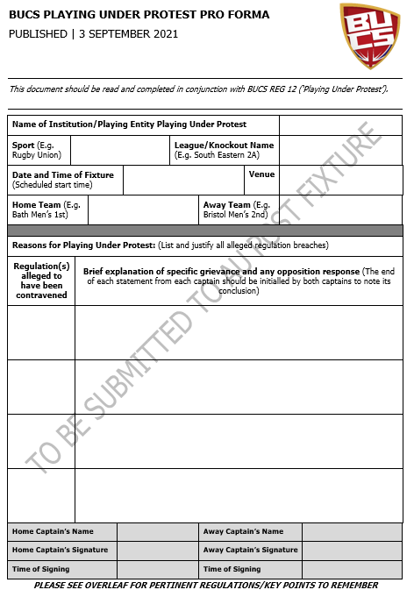

The Students’ Union at UWE has a zero walk-over policy for fixtures and competitions. Any club that concedes a walkover, will lose their funding for BUCS fixtures and will be expected to cover all of the costs associated with fixtures. This can include but is not limited to; transport costs, officials’ costs, facility costs and staff costs.

Q) Below is an example of the fines the club may receive for conceding a walkover during a knockout competition. Fill in the blanks for the monetary value of each fine.

 | One or more walkovers
National Championship and National Vase | An automatic £______ fine and loss of all BUCS points allocated to the knockout competition
National Trophy | An automatic £______ fine and loss of all BUCS points allocated to the knockout competition
Conference Cup / Trophy / Shield | An automatic £______ fine and loss of all BUCS points allocated to the knockout competition

The Students’ Union at UWE and UWE Bristol Sport, have a contractual agreement with a kit provider for the production of all sports kit, leisurewear and social clothing. All students must adhere to the contractual agreement and rules regarding kit.

There are a few things to remember when ordering kit:
- Liaise with the Club Development manager and contractual representative.
- There are ‘rules’ to follow when ordering sport kit and leisurewear (such as all upper body items must be in red).
- Make sure all kit is paid for or budgeted for.
- Only give out kit to those who have paid for it.
- Do not order anything without permission from the Students’ Union.
- Do not sign any contracts or agreements with any other kit provider.
- Do not order anything from another supplier.
- Ensure you leave plenty of time for kit orders.

Drugs and Alcohol Service

UWE Bristol does not endorse the use of alcohol and other drugs but recognises that students may choose to do so.
To prioritise the welfare and wellbeing of our community we apply the principles of harm reduction. This is to enable students to have choices and information about their drug use.
We do this by offering UWE Bristol’s Drugs and Alcohol Service to students who would like to discuss their substance use with a professional.
Our Drugs and Alcohol Service can provide advice, information and support to students who use drugs including alcohol. We offer three support options.
Harm Reduction intervention: One 1-to-1 appointment. These sessions are educational and focus on how to reduce harm associated with substance use. They are an opportunity to ask questions and explore evidence-based advice and information. These conversations can be about your own or someone else's substance use.
Goal Setting: Six 1-to-1 appointments. These sessions can be used to help you change your relationship with substances. We can support you to take control by reducing, taking a break or stopping completely.
Relapse prevention: Three 1-to-1 appointments. Some students will have decided they no longer want a relationship with drugs or alcohol. For some people stopping is the easy bit but having the tools to maintain this whilst at university can require extra support.
How to book: to book an appointment, you can complete a self-referral form which can be found here.
Which session is right for me? These options will be discussed with you at your first appointment. You don’t need to decide what kind of support you need before speaking to the practitioner, you will explore this together.
There may be circumstances where UWE Bristol’s drug and alcohol support isn't appropriate and we will support you to access community drug and alcohol services such as Bristol Drugs Project or Developing Health and Independence.
For more information please head to; https://www.uwe.ac.uk/life/health-and-wellbeing/stay-fit-and-healthy/alcohol-and-drugs

UWE Anti-sexual Violence Service

What is the Anti-Sexual Violence Service?
UWE’s Anti-Sexual Violence Service provides a non-judgemental, inclusive, and confidential space for students to seek support if they have experienced sexual trauma of any kind, even if they don’t want to report something. We can give them unbiased information about the reporting processes with the police and university so they can make the best decision for themselves.
It’s an appointment-based service, offering face-to-face, telephone or video call appointments from every campus. We offer 3-6 sessions to students, dependant on need. For more information, please go to the Anti-Sexual Violence Service website.
Please note that this is not a crisis service, if you have a serious concern about your own or another student’s welfare, please contact:
24/07 Student Support Team via the UWE Bristol Serious Concern Phone on 0117 32 84000.
In an emergency, call 999 or call the 24/07 NHS Mental Health Crisis Response Line on 0800 012 6549.
Support services available for sexual trauma in the south west can be found here.

Timeline of Events & Extra Opportunities

There are a number of events that will happen throughout the academic year that you and your society/club will be able to attend. Some of these events are listed below. You can use the space below to add the confirmed dates of these events, as they are confirmed.

EVENT | DATE
Fresher’s Fair Briefing | September TBC
Captains Briefing | September TBC
Glenside Welcome Fair | September / October TBC
Bower Ashton Welcome Fair | September / October TBC
Frenchay Freshers’ Fair | September / October TBC
Start of BUCS Fixtures | October TBC
Society/Sports Conference 1 | November TBC
Society/Sports Conference 2 | February TBC
Society/Sports Conference 3 | March / April TBC
Sports Club Photo Day | March / April TBC
The Students’ Union Leadership Elections | March / April TBC
Sports Clubs & Society Committee Elections | March / April TBC
Societies Awards 2025 | May TBC
Sports Awards 2025 | May TBC

Q) Are there any events that your club/society are planning to run/attend? What are the dates for these? Use the space below to plan your events for the year!

Event | Date

There are a number of extra training opportunities available to club/society and committee members, which will help develop your skills and enhance your CV. Make sure you book onto these as they become available, and check which are mandatory for your committee position!

- First Aid course – Emergency First Aid at Work
- Student Minds Mental Health in Sport Workshop – also available for societies
- Alcohol Awareness Training
- MiDAS training

We hope that you have enjoyed your committee training, we look forward to working with you over the next academic year and seeing what you and your society/club can achieve! Below you can find some ‘words of wisdom’ from previous committee members!

“Give one piece of advice for next year’s committee members”
Do things on time | Work hard, play hard | Care | Don’t stress over things you can’t control
Stay on top of things | Be open to feedback from members | Plan stuff early or it will never happen | Communicate with the rest of the club
Spend money (use the club budget) | Split the work, be responsible | Be organized | Enjoy it!
Plan a lot | Communicate | Make full use of the opportunities available | Plan your time effectively in order to have your most efficient committee
Actively engage with the rest of the club in decisions | Cooperate and support each other, split the responsibility | All do your bit | Make sure your committee know who each other are
Explanations must be clear to your members | Help each other | Cross-check all deadlines early | Take full advantage of all opportunities available
Don’t be scared to ask for help | Delegate to other committee members and stay on top of things | Plan trips far in advance, especially if transport required | If in doubt, ask!
Meet other committees | Build a good relationship with the SU | When in doubt, ask Alice | Build a sense of community within sport

Contact List

Students’ Union:  Muhammad Habib - VP Sports and Health  vpsports@uwe.ac.uk  Umar Abbasi - VP Societies & Communication  vpsocsandcomms@uwe.ac.uk  Kelly Howard - Opportunities Manager  kelly.howard@uwe.ac.uk 0117 32 87731  Alice Willumsen - Club Development Manager  alice.willumsen@uwe.ac.uk 0117 32 81088  Ryan Sampson - Club Coordinator  ryan.sampson@uwe.ac.uk 0117 32 81224  Magdalena Mohorkova – Societies Development Coordinator  magdalena.mohorkova@uwe.ac.uk 0117 32 81189  Opportunities Team  suopportunities@uwe.ac.uk | Centre for Sport Team:  Guy Coles - Performance Sport Manager  guy.coles@uwe.ac.uk  Tamara Getter - Sport Experience Manager  tamara2.getter@uwe.ac.uk  Vicki Moulder - Sport Development Coordinator  vicki.moulder@uwe.ac.uk

